

Name: ______________________ Seat # ____
Homework 4 - On Lecture 4 - Classes II
(100 points) Hours:

The homework is to be turned in as a PAPER AND PENCIL i.e., HANDWRITTEN ANSWER ONLY!(with your terminal #!) in the first ten minutes of the due date class.

Also an implementation in NetBeans Java is ALSO required, thus you are to submit the ZIPPED project to BB and download it in 232 PGH the first 10 minutes of class. Hardcopy with screenshots of the running program and the SOURCE CODE are also needed.
TURNING IN THE HOMEWORK INSTRUCTIONS will be PENALTY OF -10 points.
I UNDERSTAND THAT TURNING ANOTHER’s WORK IN is CHEATING.
I UNDERSTAND THAT ANY KIND OF DISSEMINATION of this WORK is CHEATING.

I CERTIFY THAT THE HOMEWORKs SOLUTIONs ARE MY OWN WORK!
V
X
?
SIGNATURE:

HOMEWORK CHECKLIST (YOU MUST GRADE YOURSELF!):
TA check, is Homework4.doc & Homework4.zip
in BB?

- DID TURN IN HOMEWORK INSTRUCTIONS?* -10 points

- 1.? 33 points
- 2.? 12 points

- 3.? H & E (attach to BB) – WORD ONLY 55 points

- Homework4 JAVA.zip NOT submitted to BB? * -35 points
- Homework4 JAVA.zip NOT running in class? * -35 points

- If NOT, do not enter anything in the box!
TA grade or check

PLEASE ENTER YOUR GRADE IN THIS BOX:

By Hand?

Screenshot?

I understand that if the .zip file is NOT in BB and I did not check the BOX, I will get a ZERO for the Homework!

1. (33 pts) (BY HAND):
a. (3 pts) Can a class contain both static and nonstatic (that is, regular) methods?

ANSWER:

b. (3 pts) Can you invoke a nonstatic method within a static method?

ANSWER:

c. (3 pts) Can you invoke a static method within a nonstatic method?

ANSWER:

d. (3 pts) Can you reference an instance variable within a static method? Why or why not?

ANSWER:

e. (3 pts) What is the difference between a static variable and an instance variable?

ANSWER:

f. (3 pts) Can you use an instance variable ( without an object name and dot) in the definition of a static method of the same class? Can you use an instance variable (with-out an object name and dot) in the definition of a nonstatic (ordinary) method of the same class?

ANSWER:

g. (3 pts) Can you use a static variable in the definition of a static method of the same class? Can you use a static variable in the definition of a nonstatic ( ordinary) method of the same class?

ANSWER:

h. (3 pts) Can you use the this parameter in the definition of a static method?

ANSWER:

i. (3 pts) What is the output produced by the following code?

Character characterObject1 = new Character(' a');
Character characterObject2 = new Character(' A');
if ( characterObject1. equals( characterObject2))
System. out. println(" Objects are equal.");
else
System. out. println(" Objects are Not equal.");

ANSWER:

j. (3 pts) Suppose result is a variable of type double that has a value. Write a Java expression that returns a string that is the normal way of writing the value in result.

ANSWER:

k. (3 pts) Suppose stringForm is a variable of type String that names a String that is the normal way of writing some double, such as " 41.99". Write a Java expression that returns the double value named by stringForm.

ANSWER:

2. (12 pts) (BY HAND)

a. (3 pts) What is a reference type? Are class types reference types? Are primitive types (such as int) reference types?

ANSWER:

b. (3 pts) When comparing two objects of a class type to see if they are “ equal” or not, should you use == or the method equals?

ANSWER:

c. (3 pts) When comparing two objects of a primitive type ( such as int) to see if they are “ equal” or not, should you use == or the method equals?

ANSWER:

d. (3 pts) Can a method with an argument of a class type change the values of the instance variables in the object named by the argument? For example, if the argument is of type ToyClass defined in Display 5.11 (A Simple Class), can the method change the name of its argument?

ANSWER:

3. (55 pts) UML Class Diagram (MICROSOFT WORD; Textual Analysis – TA Cut&Paste&Rearrange).

Enter “EXAMPLE: A Toy Class to Use in Display 5.16” from Display 5.17 in Netbeans 6.9.1 AS HOMEWORK4 build and run.
TEXTBOOK Absolute Java 4ed pp. 288-290

a. (10 pts) Draw the UML Class Diagram (REVERSE ENGINEERING)

Create a Class ToyClass2 with instance variables name and number and method set that will set the name and number, method tryToMakeEqual that takes an integer, method makeEqual that takes a class parameter of ToyClass2, the method equals and toString.

ANSWER:

Any DIAGRAM that is NOT the result of CUT and PASTE
WILL BE IGNORED (YOU WILL GET ZERO POINTS)

b. (35 pts) Create in Netbeans 6.9.1 HOMEWORK4 Project build and run .

Insert as the answer a Project screenshot (3 windows, please see the template at the end of this document).

Please make sure you submit the HOMEWORK4 ZIPPED NetBeans 6.9.1 project to Black Board!

ANSWER:

c. (10 pts) Answer the following based on b. (BY HAND):
What is the problem with trytoMakeEqual method?

ANSWER:

UML Class Diagram Symbols:

Catalog 1: name:String
Catalog

Catalog 1: addArtist(String artist) void;

Step 1: Sample Screenshot (whole screen PRINT key on the keyboard will copy the screen with the following information:

Project, Output Window, Significant Source Code

Step 2: Open a word document and paste copy of the screen!

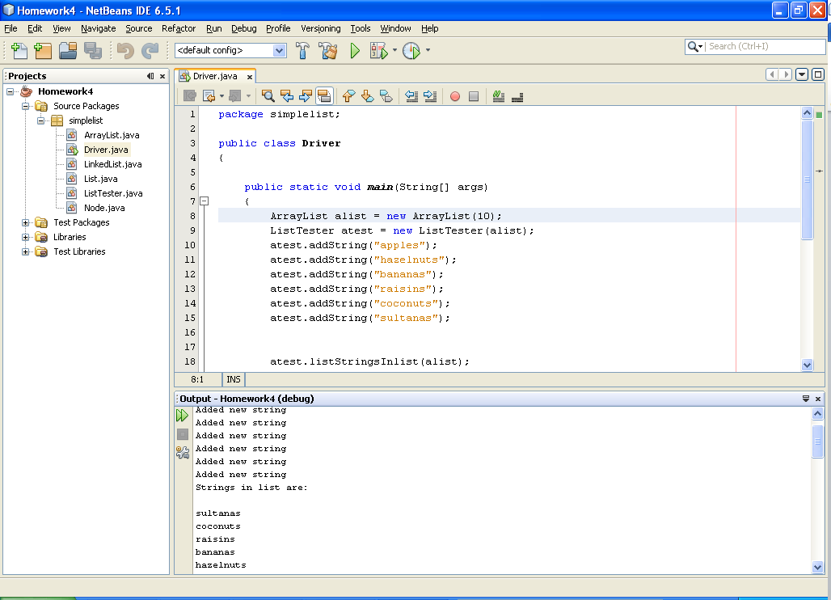
Output Window
Project
Source Code with 4 lines of comments
// COSC 1320 Semester (example: Spring 2015)
// Name: (example: John Doe)
// Document (example: Homework2.5)
// This is my own work; I will not post
Homework2.6

